1. Team 2

2. Stock Buffs

3. Elijah Boyer-Otto, Ali Siddiqui, Kai Janipalli, Stephen Le, Pranav Meka

4. Buffonomics

5.

The Politician Stock Trade Tracker is a web application that allows users to view and monitor the stock trading activity of a specific U.S. politician, beginning with Nancy Pelosi as the primary focus. The platform aggregates publicly available trading disclosures using a free API (such as Financial Modeling Prep) and presents the data in a clear, interactive dashboard. Users can see recent trades, including transaction dates, ticker symbols, and trade values, along with trend visualizations that summarize the politician’s portfolio activity over time. By simplifying access to government financial disclosure data, the application helps users better understand how political and financial actions may intersect.

The application features a secure user system where individuals can sign up, log in, and manage personalized notifications. Registered users can choose to receive email alerts whenever new trading activity is detected, keeping them informed in real time without needing to check the site manually. The backend connects a PostgreSQL database to a Node.js/Express server, ensuring that all user data (including hashed passwords and session tokens) is stored securely. The project will be containerized using Docker for consistency across environments, following the architecture standards of the course.

This project’s value lies in its accessibility and transparency. By providing an easy-to-use interface and automated notifications, the application empowers users (students, investors, or concerned citizens) to stay informed about political trading behaviors. Starting with one politician allows the team to refine data handling, API integration, and user experience before expanding the system to support multiple lawmakers in the future.

6. Our target audience will be for new and experienced stock traders. Students will be a key market since our product is available for free and many students are price sensitive to new products.

7. To empower citizens to stay informed by providing clear, real-time insights into a politician's trading activity, promoting transparency and accountability in government.

8. https://github.com/Wheatlys/Buffonomics

9. We will use an Agile methodology following the Scrum framework, organizing our work into weekly sprints and tracking progress with a Kanban board on GitHub to stay flexible and collaborative throughout the 4-week project.

10. We will be using Discord for our main form of communication. We also have a group chat on snapchat for if we need to get a hold of each other urgently.

11. Weekly Meetings: 2:30PM Friday (works for all members and TA)

12. Case Diagram:

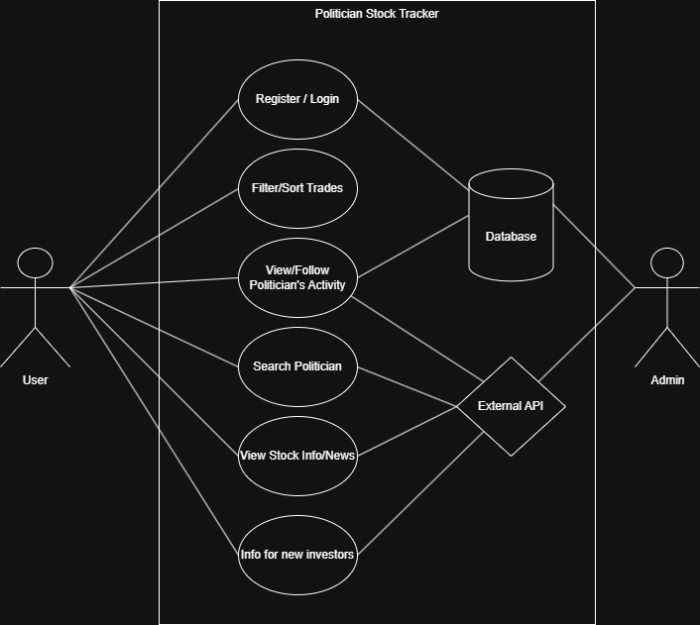

13. Wireframes:

